Guided Practice Report
Before completing this guided practice report, you should have completed the associated procedure.

Screenshots
After you have completed the procedure for the guided practice, add your screenshots below.
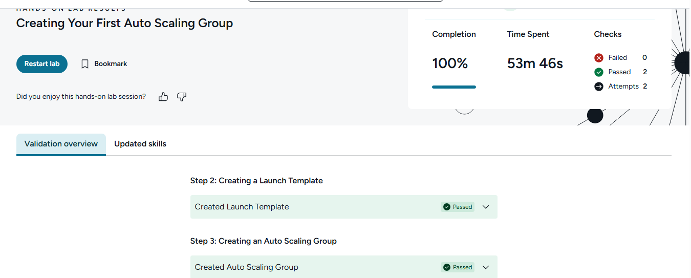

Reflection Questions
After you have completed the procedure for the guided practice, provide your answers to the reflection questions here.
What is the role of security groups as they relate to resources within the AWS cloud?
Security groups act like virtual firewalls for AWS resources, especially EC2 instances. They control what inbound and outbound network traffic is allowed.

What is the code added to the user data section of the EC2 instance setup useful for?
User data code runs automatically when the EC2 instance starts. It is useful for setup tasks like installing software, updating packages, or starting a web server.

Describe how EC2 auto scaling works.
EC2 Auto Scaling automatically adds or removes EC2 instances based on demand. When traffic increases, it launches more instances; when traffic drops, it removes extra ones to save cost.

